Welcome to
The Lothians Family History Society

The society aims to help like-minded people interested in family history within the Lothian areas. Whether you are a beginner or an experienced researcher, meeting together gives you the opportunity to share your interests and to learn more about researching your family heritage. The LFHS covers Midlothian, East Lothian, West Lothian, and the City of Edinburgh.

Membership Benefits:
- Access to LFHS Members Only Area
- Three seasonal newsletters a year
- Members Interests
- Attendance at monthly meetings with expert speakers on a wide range of interesting topics and subjects
- Attendance at any Zoom meeting run by the LFHS Committee
- Attendance at monthly workshop sessions at Loanhead Library
- Access to Ancestry.co.uk and the worldwide web
- Access to other society’s in Scotland Journals/Newsletters
- Access to our ever-growing library of research materials
- Social benefit of meeting LFHS members and sharing family history research

Members of the society have been actively gathering and transcribing Monumental Inscriptions and those are available for sale.

Our members are all over the world – and with such a wide membership, there are lots of possible links.

Society Information:

Chairman: Lorna Kinnaird
Email: lothiansfhs@hotmail.com

Membership
Secretary: Sheila Petrie
Email: lothiansfhs@hotmail.com

Website: https://www.lothiansfamilyhistorysociety.co.uk

Meetings:

Every Wednesday at 7pm, except July and August at the Lasswade Centre, Bonnyrigg.

Monthly (the third Thurs) at Loanhead Library from 10.30am-2pm.

Evening visits to New Register House in Edinburgh take place on the fourth Wednesday of the month. These can be booked in advance at cost of £10 per person.

LFHS Membership Application Form

Name:  (Mr/Mrs/Miss/Ms) | Email:
Address:  Postcode: | Tel/Mobile:
Membership of the Society is by annual subscription, and you will receive three issues of our Newsletter, during the year.  We would prefer the payment of £15 to be paid through bank transfer:  Sort Code: 80-06-29  Account number: 00547426  Name of account: The Lothians Family History Society:  Note: Please remember to put your full name as reference (e.g. John A. Smith.)  Memberships Fees:  Membership (one person) Including e-membership overseas £15  or  Payment Enclosed:  £______________  Cheques or postal orders payable to: “Lothians Family History Society” | The Data Protection Act 2018 controls how your personal information is used by organisations, businesses, or the government. Members of the LFHS have their details stored on computer for administration and research purposes only and will not be given, lent, or sold to any third party. By signing below, you are giving our Membership Secretary permission to contact you as a Member and to allow your email address only to be passed to members who have participated in the Members Interest.  By signing below you are giving the society permission to contact you via email in relation to newsletters or correspondence.  Signature:  Name:  Date: _____________________
Members Interests

Only include Midlothian, East Lothian, West Lothian, or City of Edinburgh

SURNAME
DATES
PARISH & COUNTY

SURNAME
DATES
PARISH & COUNTY

SURNAME
DATES
PARISH & COUNTY

SURNAME
DATES
PARISH & COUNTY

SURNAME
DATES
PARISH & COUNTY

SURNAME
DATES
PARISH & COUNTY

SURNAME
DATES
PARISH & COUNTY

SURNAME
DATES
PARISH & COUNTY

Surnames of Interest to Society Members can be found online in the Members Only Area of the LFHS website.

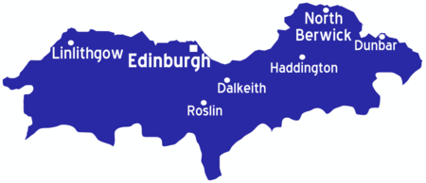

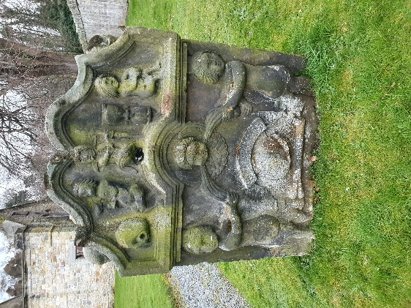

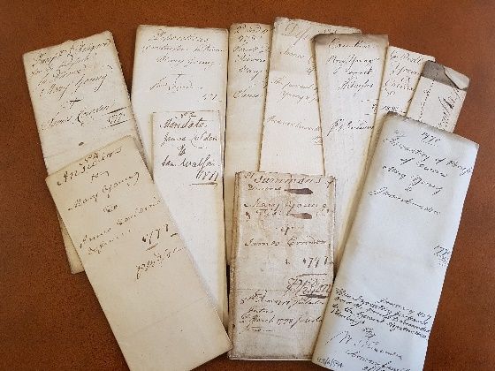

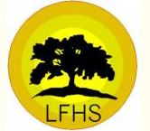

The Lothians Family History Society

Membership Application Form

At

Lasswade High School Centre Eskdale Drive Bonnyrigg, Midlothian, EH19 2LA

